Aidan Gorospe
CS - 360
Professor Dimarzio
February 25 2026
Project Three: Launch Plan

For this project, I chose to tackle making an event planner, one that allows you to add, edit, and remove events from a database, being accessible via username and password. The first stage was creating a nonfunctional model of the UI and the screens to figure out the proper layout and needed functions for the product. The login would contain inputs for username and password, with two buttons to either log-in or sign-up. The Sign-in would only work if the username hasn’t been used with a previous account, and the login will not work with a username not recognized in the database.
The next page would be the main page containing: a list of events, two text boxes for the user to add event and event description, a button for the user to create an event with the previous credentials, a switch to enable sns notifications, and extra textviews that would display extra instructions for the user. Visuals for the UI are shown below:
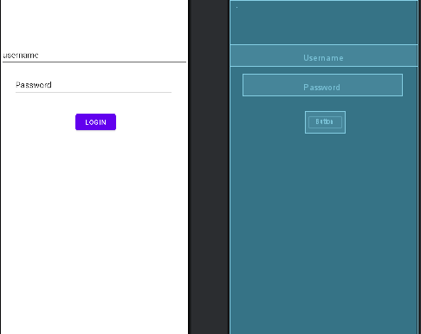
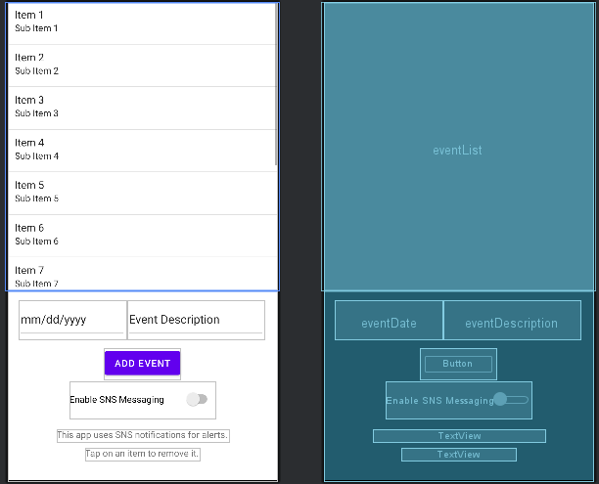
This app will be compiled in Android 16, with the version of Gradle running 9.1. I wanted to keep things somewhat modern to account for the fact that even though most users aren’t running the latest version of Android, this would be future-proofing for a large amount of time. This would also mean not being restricted by older tools to improve the application. Lastly, for permissions, I would only have the user be prompted to accept SNS Notifications via a switch on the main page, and would notify the user whenever an event is added or deleted successfully.
After finishing the code to get most of the requirements working, I find myself unsatisfied with the current state of the app, mostly due to time constraints. Due to this, I have developed a launch plan that will see me continue to work on implementing missing or additional features from the original document, improving UI, and reforming/refactoring existing code to appear more legible. Firstly would be properly incorporating the Account system into the database for it to be fully functional, next would be changing the listview to be more legible to standard users, as well as a bit more separated to avoid misclicks. From there more quality of life changes to improve the user experience would be added based on testing.

